Expt. No: 1 | WORD PROCESSING
Date:27.11.2020 | WORD PROCESSING

Aim:
To create a document using Ms Word and to perform the following operations
  - Document creation, Text manipulation with Scientific notations
  - Table creation, Table formatting and Conversion
  - Letter preparation and mail merge
Description:
Word Processing
Word Processing is using a computer to create, edit, and print documents. Of all computer applications, word processing is the most commonly used. To perform word processing - a computer, word processing software and a printer are required. Word processing software enables the user to do the following:
- To create a document
- Store it electronically on a USB or on a computer
- Display it on a screen
- Modify or format it by entering commands and characters from the keyboard
- Print the document on a printer
Document creation
To create a document, simply open Word, select a blank document or template, and start typing. Word offers many professionally designed templates to help you create letters, resumes, reports, and more.
Create a blank document
- Open Word. Or, if Word is already open, select File -> New.
- Select Blank document.
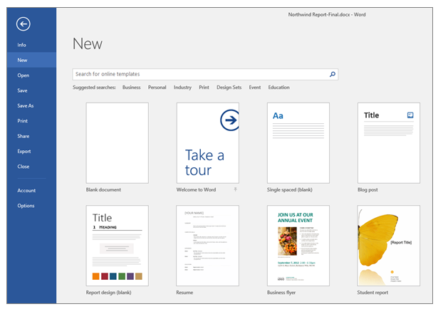
Text manipulation
Text manipulation usually refers to the ability to change words, sentences and paragraphs which have been typed. The manipulation can involve the changing of the characters (letters and symbols), adding line breaks, direction of the text and changing the case (CAPITAL letter or small letter) of the characters.
- The most common formatting which are applied in Word are Bold, Italic, Underline, font styles, font size and coloured font.
- Insert text at any position in your Ms Word Document , arrange, space, and align your lines and paragraph, insert and manage Indentations, insert and edit Bullets & Numbering and add formatting to text.
Arrange, Space, and align lines and paragraphs
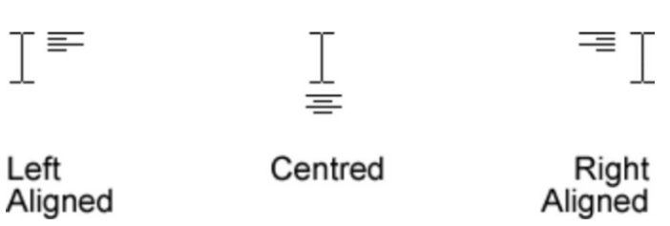
- In Ms Word, a Paragraph is a continuous flow of text, until you press the Enter key. Whereas a line is a single line on the page, hence a paragraph is made up of several lines. You have the option of adjusting paragraph spacing as well as line spacing.
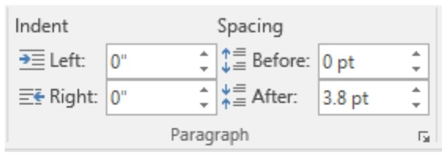
The shortcut for line spacing are;
Ctrl+1 = single line spacing;
Ctrl+5 = 1.5 lines spacing while
Ctrl+2 = double line spacing.
You may want to use other line spacing apart from the ones listed above. To do that click on the arrow below the paragraph menu to open the paragraph settings dialogue box.
Formatting Ms Word Text
When you type in Ms word, the default font is applied with the default size. There are instances where you are not okay with these defaults, then you have to format the text to your choice. With format text, you will be able to change the font face, font size, make font Bold, Italicize and underline the text.
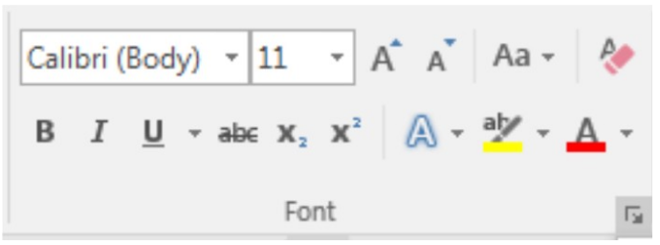
The keyboard shortcuts for most of the commands.
Ctrl+B = Bold
Ctrl+I = Italics
Ctrl+U = Underline

Insert and edit Bullet & Numbering
Bullets & Numberings are useful when you have a list in your Ms Word Document. With bullets or numbers, you can differentiate the different segments of the list. Bullets are symbols representing each point on a list, while a numbered list is numbered in a sequential order.
Scientific notations
Scientific notation is a way of expressing numbers that are too large or too small to be conveniently written in decimal form. It may be referred to as scientific form or standard index form, or standard form. Example: 3.6 × 10¹²
Table
A table is a grid of cells arranged in rows and columns. It can be useful to present data in a table inside a word processing document because it is displayed in an organised and easy to read format. Tables can be sorted, formatted, merged, aligned, shaded and coloured
Insert Table
Click Insert -> Tables -> Insert Table from the dropdown menu. In the Insert Table dialog box, enter the number of columns and rows you want in this table (four columns and five rows).
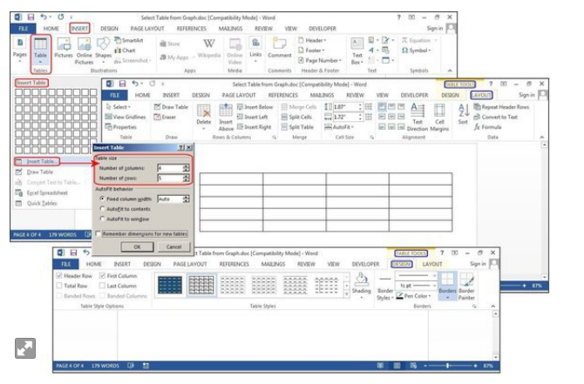

Format a table
After you create a table, Microsoft Office Word offers many ways to format that table. If you decide to use Table Styles, you can format your table all at once, and even see a preview of what your table will look like formatted in a particular style before you actually apply the style.
Table Formatting
- Add or remove borders to the whole cell or specified cell
- Add a cell, row or column
- Delete a cell, row or column
- Merge cells
- Split cells
Table conversion
- Select the rows or table you want to convert to text.
- On the Layout tab, in the Data section, click Convert to Text.
- In the Convert to Text box, under Separate text with, click the separator character you want to use in place of the column boundaries. Rows will be separated by paragraph marks.
- Click OK.
Mail Merge
Mail merge is the batch mailing of letters - using a letter template and a data file or address database. Instead of a business or college creating multiple copies of the same letter to send out in the post, one letter and one data file is created. The letter and data file are merged together which means the names and address are automatically added to each of the letters and envelopes from the database or data file.
Procedure to create mail merge
- In mailings, Click start mail merge
- In start mail merge, click step by step mail merge wizard
- It shows six steps to create a batch mailing of letters.
- In step 1, choose letters option in select document type wizard and press next button to start document.
- In step 2, choose the current document option in the select starting document wizard and press next button to select recipients.
- In step 3, choose type a new list in the select recipients wizard to add new recipients and press ok to save the address list of the recipients.
- In step 4, choose address block and greetings block in the write your letter wizard to include the address list of the recipients.
- In step 5, press complete merge option to preview the letters.
- In step 6, click print option in the complete merge wizard to view and save the documents as a pdf format.
Task
- Open a new word document and perform the following tasks:
  - Justify text
  - Correct spelling errors
  - make some text as bold
  - Underline and italic style for some words
  - Save with suitable name

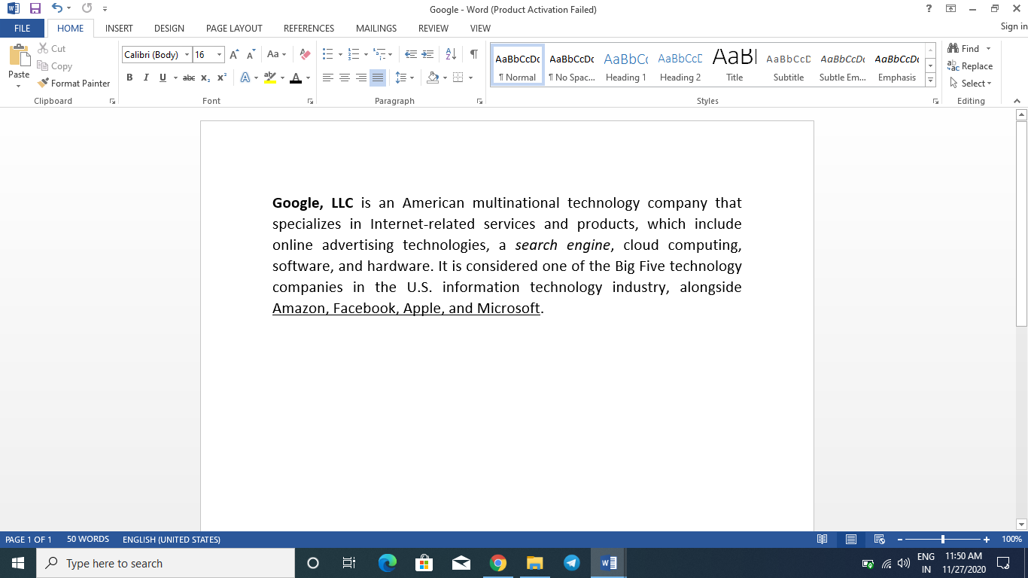
(Place your screenshot)
- Format document as below
- Line spacing of 1.5 lines
- Paragraph indent of 0.10”
- Change text color
- Change font size to 12 point .

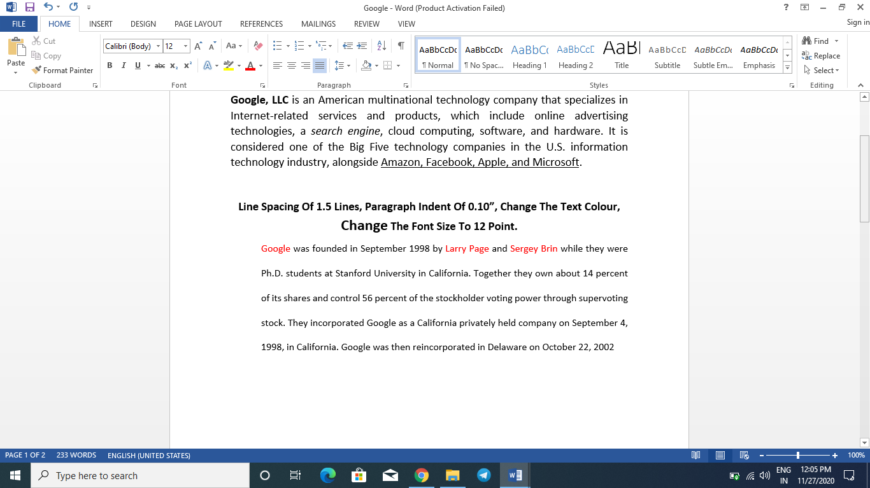
(Place your screenshot)

- Create two pages of Curriculum vitae (CV) of a B.E. graduate with the following specifications
- Table to show qualifications with proper headings.
- Appropriate left and right margins.
- Page number in the footer.
- Name in header.

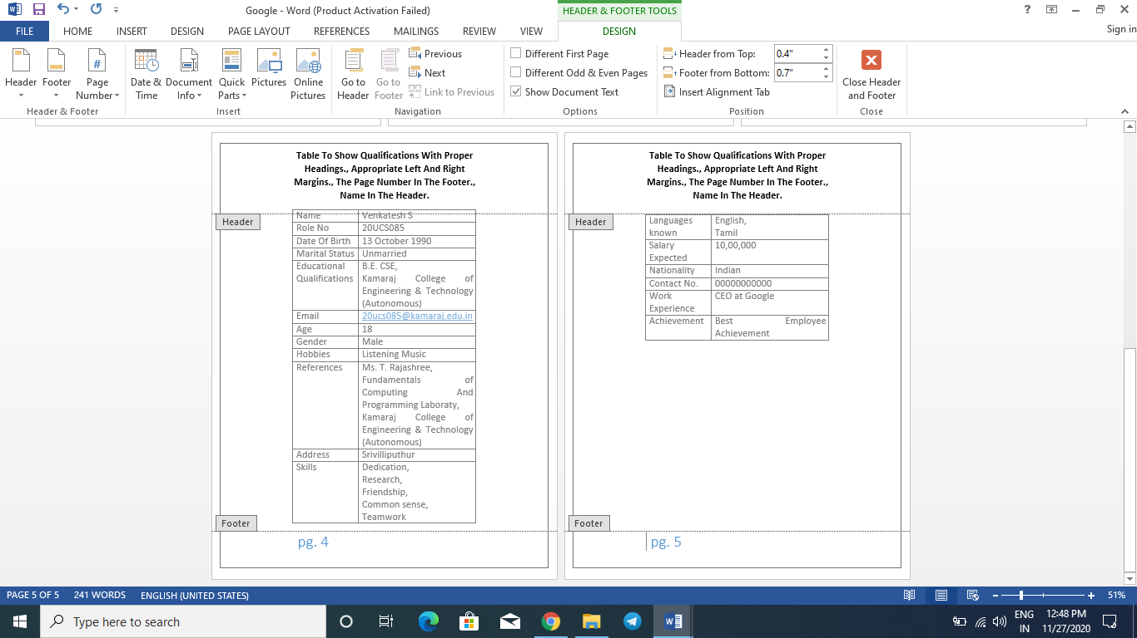

(Place your screenshot)

- Insert mathematical equation
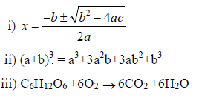
(Place your screenshot)
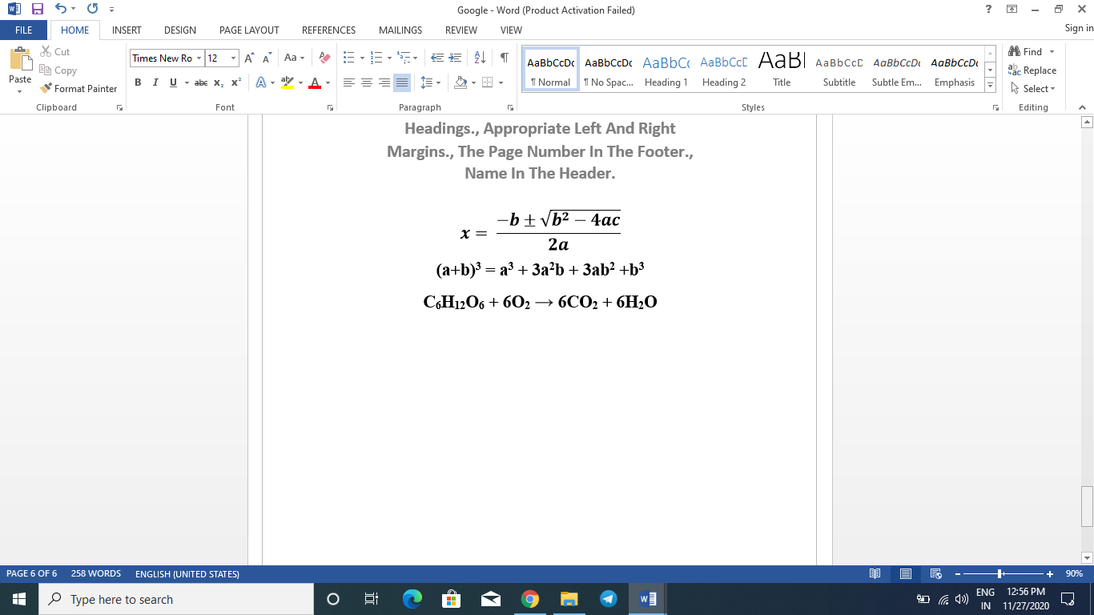

- Prepare class time table using table and perform table formatting operations
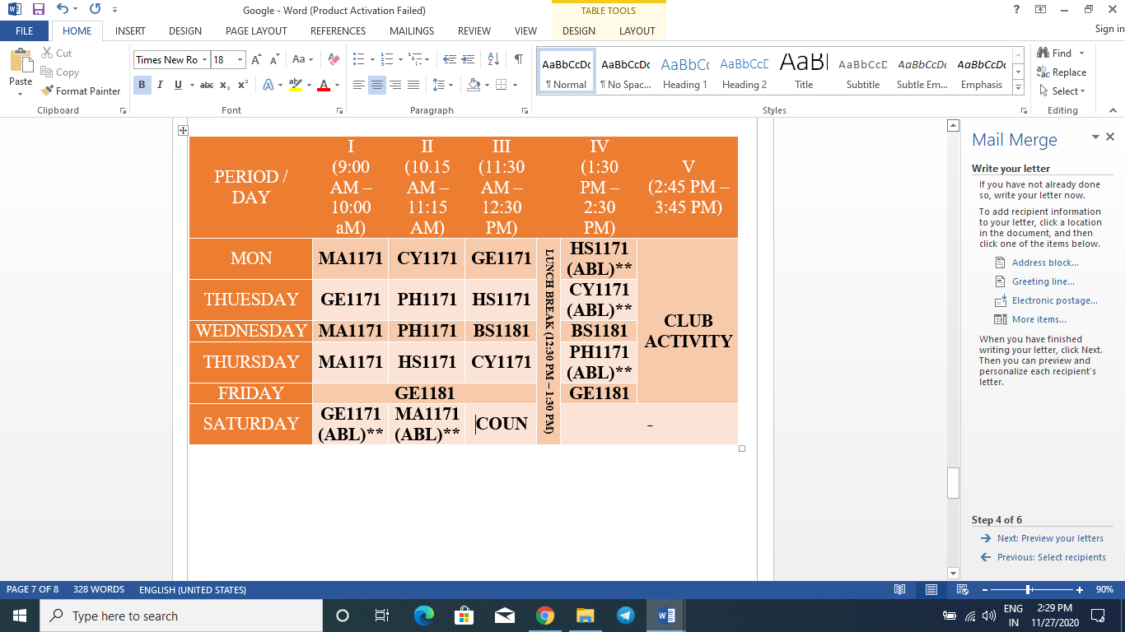

- Write a professional letter to the VRB Company by using letter Wizard.
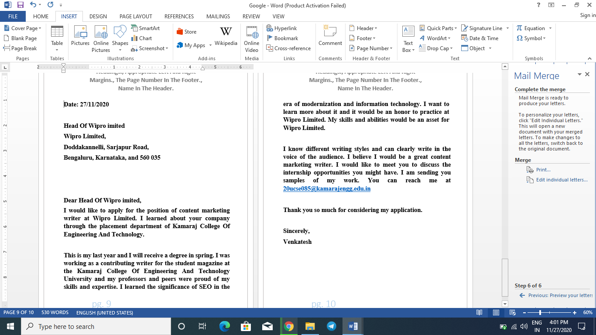

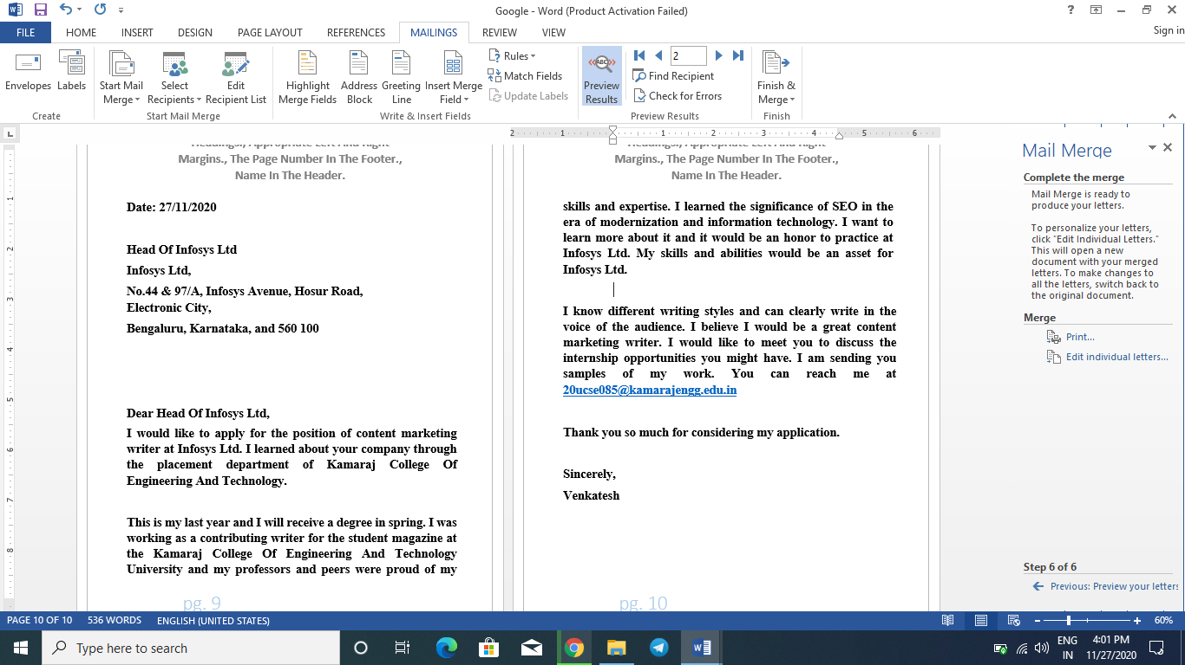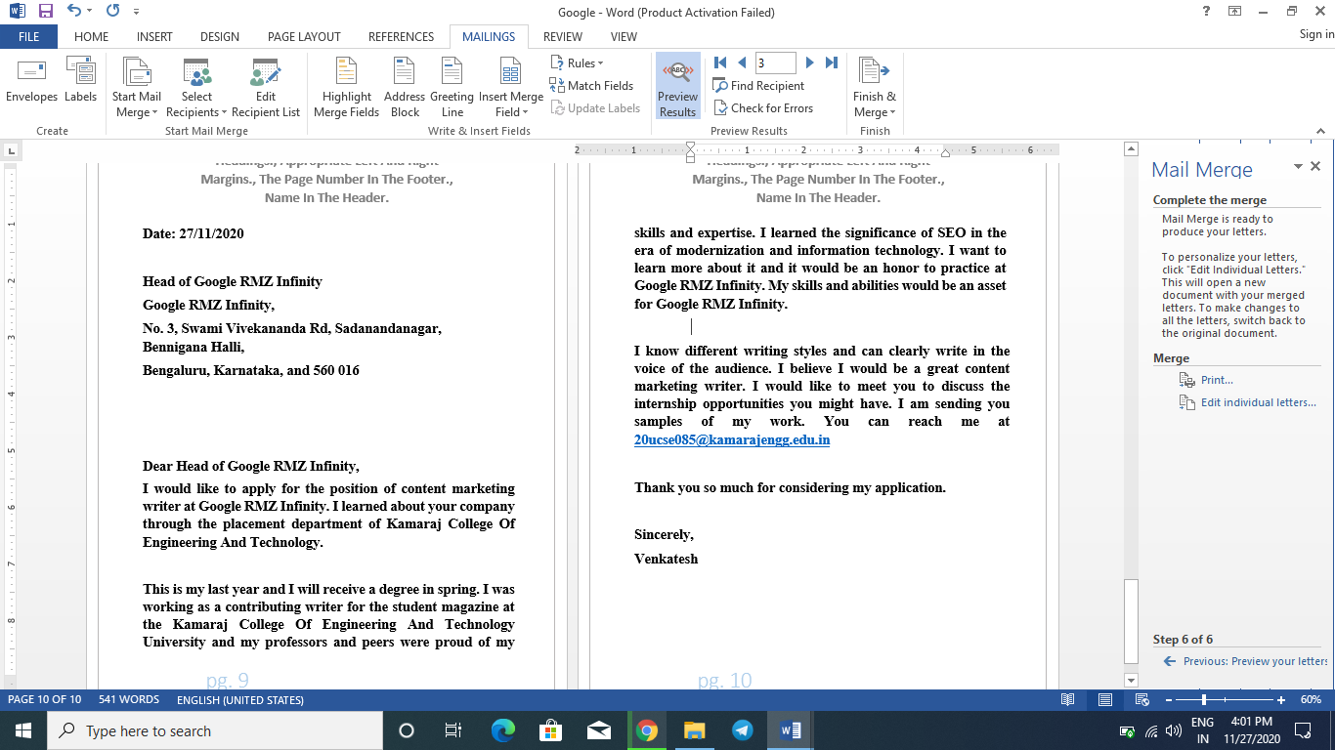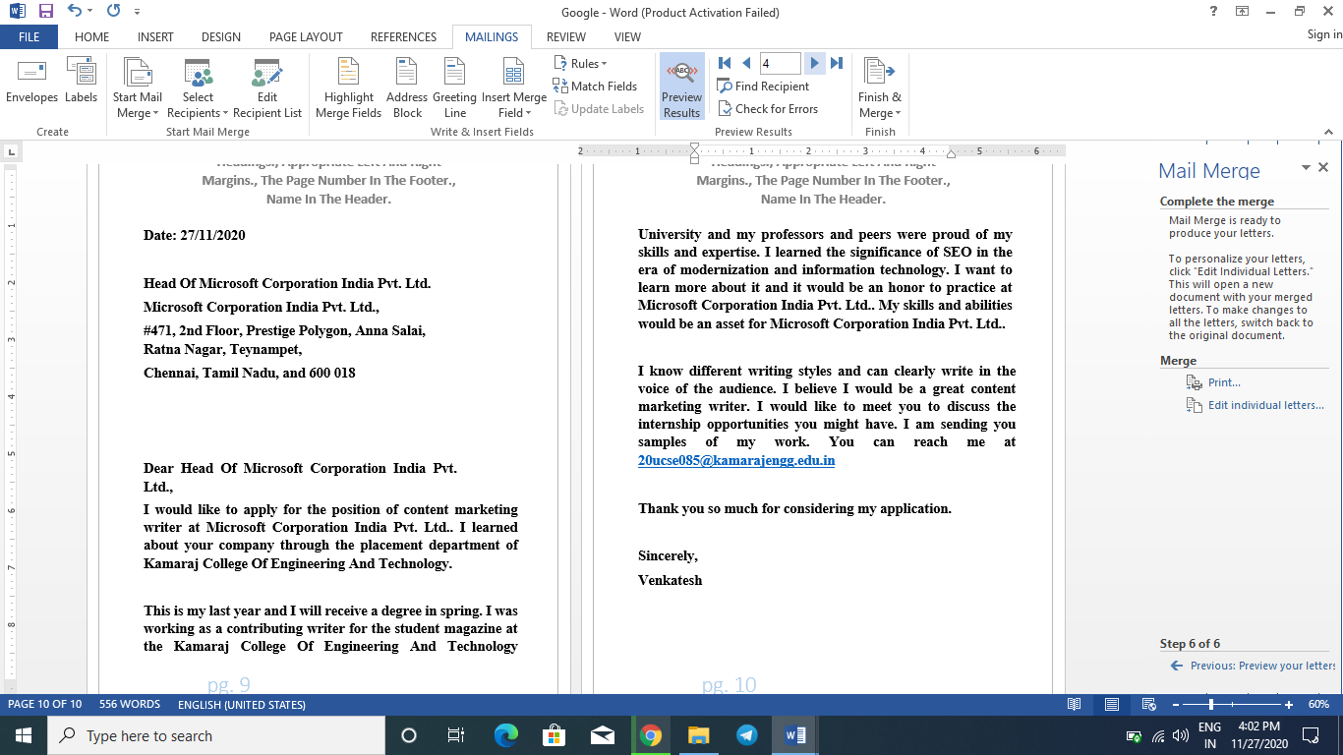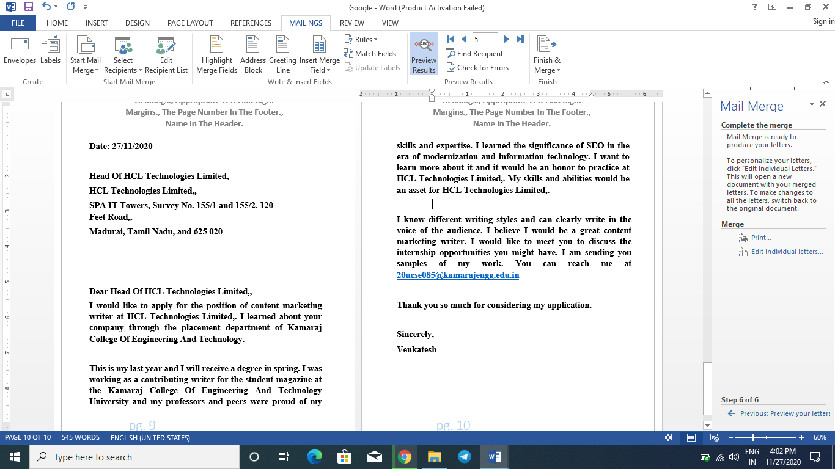

Result
Thus the word document is created successfully.

